To further examine run value over the course of the 2022 Major League Baseball season I chose to examine hitters that should be more likely to have higher run values. The two players I took a closer look at were Jeff McNeil and Luis Arraez. I chose these two as they were the batting champions in their respective leagues. I am assuming since they have the highest batting averages, they are getting hits more frequently than other players, this includes when runners are on base. After calculating the RE24 for each player they weren’t two different, McNeil with 16.87 and Arraez with 21.73. Upon further breakdown using a jitter plot we can see how each player performs in each game state.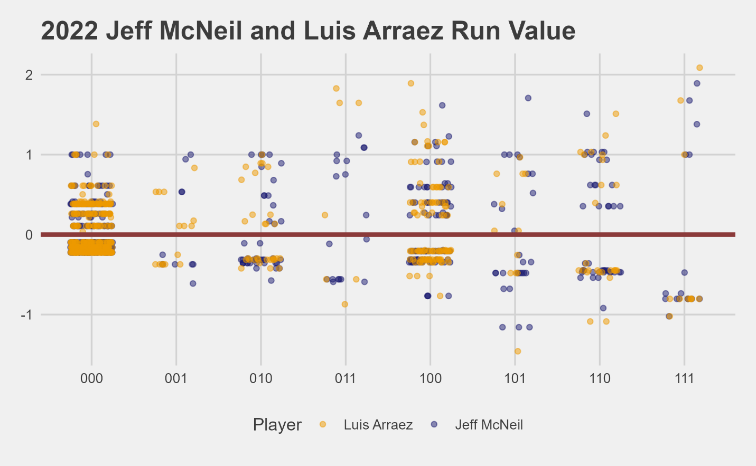
From the graph above we can see that each player has a wider range of run value as the runners get closer to third. Both Arraez and McNeil add more value in situations with no baserunners or a runner on first. This may be skewed as there aren’t as many points with runners on second or third during 2022 as Arraez and McNeil were both leadoff hitters that year. But overall, in those situations they are either having a large positive or negative run value as opposed to more consistent smaller run values in less impactful situations. This shows the are likely being placed in the correct spot in the lineup as they deliver more frequently with less runners on base.

